Upcoming IRSJA Meetings

Spring, 2016: April 20-24 -- Millennium Harvest House, Boulder, Colorado.

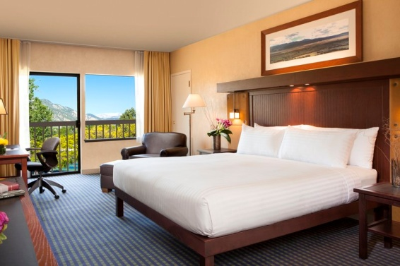

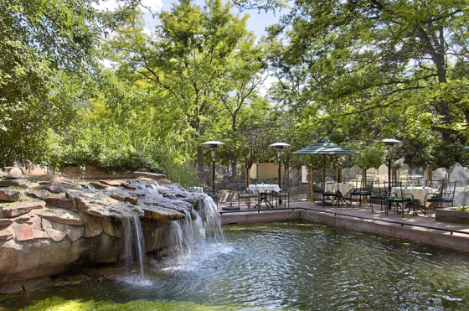

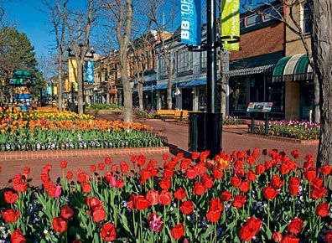

The Millennium has recently updated and/or remodeled many guest rooms as well as the outdoor garden area adjacent to the Boulder Creek Trail.

Reduced room rates of $139 apply until March 23, 2016. To register, use this dedicated registration page for the IRSJA.

https://reservations.millenniumhotels.com/ibe/details.aspx?propertyid=13524&nights=1&checkin=04/17/2016&group=1604IRSJA1

You may also register by phone, fax or email:

E-Mail: Guests may e-mail their reservation request to boulder.reservations@millenniumhotels.com. Please refer to our group code: 1604IRSJA1

Fax: Guests may fax their reservation request to (303) 442-3821. Please have them refer to group code: 1604IRSJA1

Telephone: Guests may call the hotel toll free at (800) 545-6285. Please have them refer to group code: 1604IRSJA1

Fall, 2016: October 19-23 –Renaissance Charlotte Suites, Charlotte, North Carolina

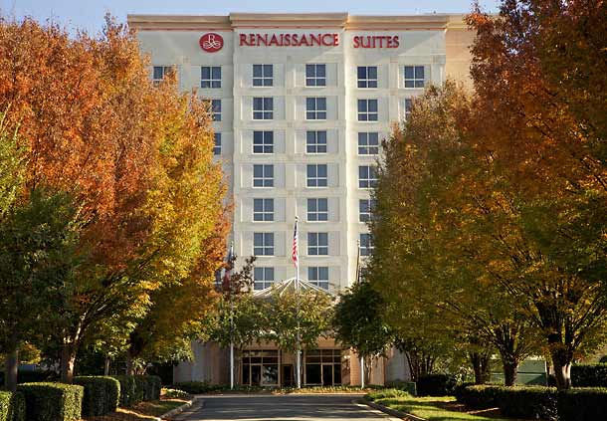

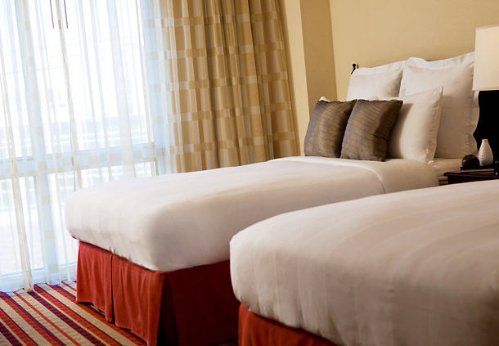

This all-suite hotel is located five miles from the Charlotte Douglas International Airport, with a free airport shuttle. Each suite has a separate living room with a pullout sofa bed to accommodate up to three people. Our reduced room rate is $152. The hotel was awarded a certificate of excellence by Trip Advisor based upon excellent customer reviews.

The hotel’s website:
http://www.marriott.com/hotels/travel/cltbr-renaissance-charlotte-suites-hotel/

Spring, 2017: April 26-29 -- Millennium Harvest House, Boulder, Colorado

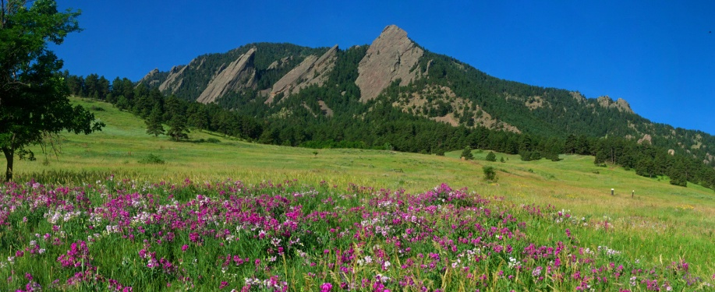

Fall, 2017: October 18- 22—Hilton Minneapolis/St Paul Airport-Mall of America Hotel

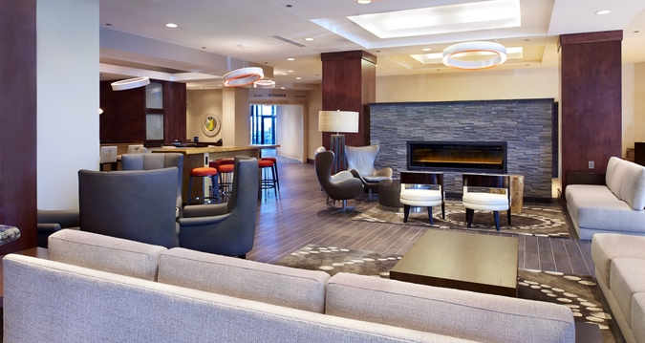

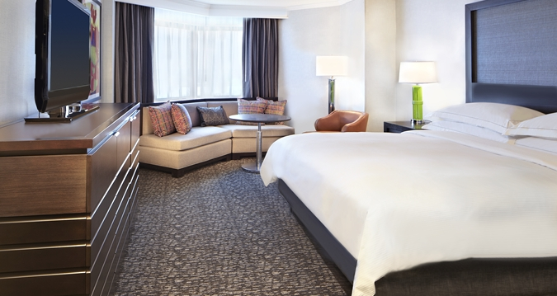

Located 3miles from the Minneapolis-St. Paul International Airport, the hotel provides a free shuttle to the airport and the nearby Mall of America. The Minnesota Valley National Wildlife Refuge, with extensive walking trails, is within walking distance, as is light rail to downtown Minneapolis. The hotel is rated 4 stars (out of 5) by Trip Advisor customer reviews. The room rate for our meeting is $145.

This meeting will be our next Invitational Conference, with attendance to the program portion of the meeting open to attendees of IRSJA seminars and study groups led by our members.

The hotel website is
http://www3.hilton.com/en/hotels/minnesota/hilton-minneapolis-st-paul-airport-mall-of-america-MSPAHHF/index.html

Spring, 2018: April 18-21-- Millennium Harvest House, Boulder, Colorado

